5️⃣ Objects must support COMMUNICATION ❌ NOT compulsory
(method call only — NO data here)
Definition reminder ⭐
Communication = calling another object’s METHOD via reference

✅ Correct COMMUNICATION
class Course {
void startClass() {
System.out.println("Class started");
}
}
class Student {
Course course;
}
studentObj.course.startClass();
✔️ student → course → method
✔️ METHOD called
✔️ This is communication

❌ NOT communication
studentObj.course.courseName; // ❌ data access

Counter-example (VALID association, data only)
class Course {
String name = "Java";
}

class Student {
Course course;
}
System.out.println(student.course.name);
✔ Association exists
❌ No method call
✔ Still association
🔑 Communication is OPTIONAL

6️⃣
Association is the general relationship.
Both aggregation and composition are specific forms of association.
✔️ Association works for both aggregation and composition
1️⃣ First, fix ONE core fact (this decides everything)
Both aggregation and composition REQUIRE an object reference.
So this sentence is 100% true:
Object reference is a must for any kind of association. ✅
Without a reference:
- ❌ No association
- ❌ No aggregation
- ❌ No composition

2️⃣ Now the confusion point (very important)
You said:
“If reference is must, then I think composition is not possible, only aggregation is possible.”
👉 This conclusion is NOT correct, and here is why 👇

3️⃣ Why composition DOES NOT break the “reference rule”
Look at a composition example carefully
class Engine {
}

class Car {
Engine engine = new Engine(); // reference EXISTS
}
🔴 Key observation (very important):
- engine is a reference variable
- It points to an Engine object
- So reference EXISTS
👉 Therefore:
✔️ Association exists
✔️ Composition exists
So composition does NOT violate the “reference must exist” rule.

4️⃣ Then what is the REAL difference between aggregation and composition?
Not whether reference exists
But HOW the referenced object is created and owned

🔹 Aggregation (weak association)
class Car {
Engine engine;
}

Engine e = new Engine(); // created outside
Car c = new Car();
c.engine = e;
- Reference exists ✅
- Engine created independently ✅
- Lifecycle independent ✅
👉 Aggregation

🔹 Composition (strong association)
class Car {
Engine engine = new Engine(); // created inside
}
- Reference exists ✅
- Engine created inside Car ❌
- Lifecycle dependent ❌
👉 Composition

5️⃣ This is the KEY correction (lock this ⭐)
Reference is common to BOTH aggregation and composition.
Lifecycle dependency is what differentiates them.

7️⃣ Domain-Meaningful Relationship (✔ Design Guideline, ❌ Not a Mandatory Rule)
✅ What this point REALLY means (corrected)
In object-oriented domain modeling, we model associations only between domain entities that have real-world meaning.
This is a design guideline, not a technical requirement enforced by the language.

✅ Valid (Domain-Meaningful) Associations
- Student → Course
- Employee → Department
- Person → Passport
✔ Both sides are domain objects
✔ Both represent real-world entities
✔ Relationship has business meaning
These relationships are meant to be modeled as associations.

❌ NOT Associations (Correctly Identified)
- Student → age
- Student → name
Why?
- age, name are attributes
- They describe Student
- They are not independent domain objects
- They have no identity or lifecycle
So they must be modeled as data fields, not associations.

⚠️ Important Clarification (this removes the mistake)
❌ Incorrect statement (removed):
“Relationship must be domain-meaningful”
✅ Correct statement:
Only domain-meaningful relationships SHOULD be modeled as associations in domain design.
Why this correction matters:
- Java allows associations with any class
- But good design restricts associations to domain entities

🧠 Final Correct Understanding
- Technically:
Association exists if one object holds a reference to another object.
- Design-wise:
Associations should represent real-world domain relationships, not attributes or utilitie

⭐ FINAL KILLER LINE (USE THIS)
Association is a runtime relationship between two independent domain objects,
established through references, enabling either data navigation or communication.

🔚 Tattoo-level truth 😄
Attributes describe an object.
Associations connect objects.

⚠️ NOT COMPULSORY (Optional / Design Choices)
These are NOT rules, just ways to implement association.
🔹 Constructor Injection
Employee(Account acc) { ... }
✔ Recommended
❌ Not mandatory

🔹 Setter Injection
setAccount(Account acc);
✔ Optional
✔ Useful when association changes

🔹 Access Modifier (private)
private Account account;
✔ Best practice
❌ NOT compulsory
(default / protected also work)

🔹 Getter / Setter methods
✔ Optional
✔ Used for encapsulation
❌ Association does not depend on them

🔹 Null checking
✔ Good practice
❌ Not a rule

- Use a constructor when you want to initialize values at the time of object creation.
- Use a setter method when you want to change or set the value after object creation.
Example:
class Student {
String name;

// Constructor
Student(String name) {
this.name = name;
}

// Setter
void setName(String name) {
this.name = name;
}
}
Usage:
Student s = new Student("Pavan"); // constructor
s.setName("Kalyan"); // setter

📘 One-to-One Association — Definition
One-to-One Association is a HAS-A relationship between two classes in which one object of a class is associated with exactly one object of another class.
In this relationship:
- One class holds a reference to another class
- Both objects have independent lifecycles
- The relationship is not inheritance (IS-A)

🔗 Establishing One-to-One Association
A one-to-one association can be created in two ways:
1️⃣ Constructor Injection
The dependent object is passed through the constructor at the time of object creation.
👉 Ensures the association is set when the object is created.
Example idea (concept):
Employee is created with an Account.

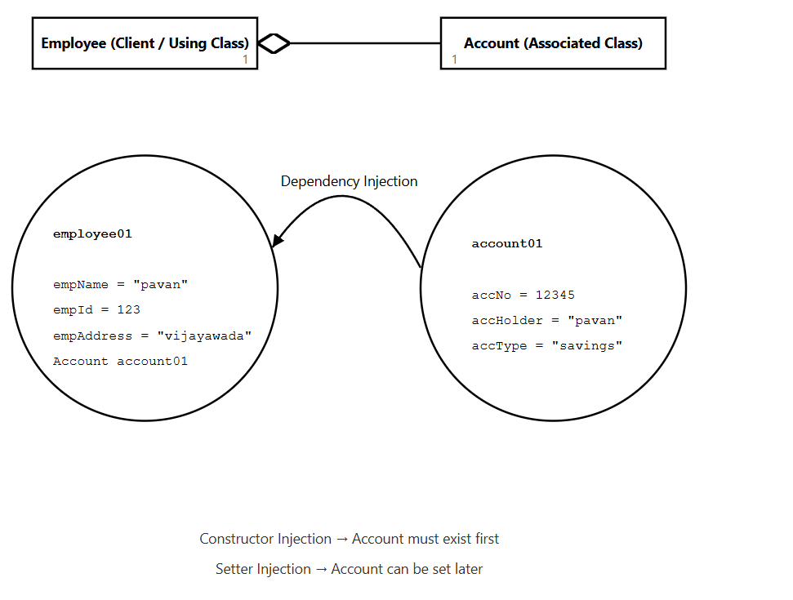

Eg: Account01, Employee01, One_One_Association_Using_Constructor

1️⃣ Constructor Injection → Account must exist first ✅
Why this is TRUE
In constructor injection, the dependency is passed as a parameter while creating the object.
Example:
Account account = new Account(12345, "pavan", "savings");

Employee employee = new Employee("pavan", 123, "vijayawada", account);
Logical reason
- The constructor expects an Account object
- Java will not allow object creation without passing it
- So the Account object must already exist
What happens if it doesn’t exist?
new Employee("pavan", 123, "vijayawada", null); // ❌ invalid design
👉 This either:
- breaks business logic, or
- causes runtime errors later
✔ Conclusion
In constructor injection, the dependency must be created first, because it is required at object creation time.

2️⃣ Setter Injection
The dependent object is set later using a setter method, after the object is created.
👉 Allows the association to be changed at runtime.
Example idea (concept):
Employee is created first, Account is assigned later.

Eg: Account011, Employee011, One_One_Association_Using_Setters_Getters

Setter Injection → Account can be set later
Why this is TRUE
In setter injection, the object is created without the dependency.
Example:
Employee employee = new Employee("pavan", 123, "vijayawada");

Account account = new Account(12345, "pavan", "savings");

employee.setAccount(account);
Logical reason
- Constructor does not require Account
- The object can exist in a partially initialized state
- Dependency is attached after creation
This allows:
✔ Lazy assignment
✔ Changing dependency at runtime
✔ Optional relationships

By seeing the code how to judge it is One to Many or Many to One
Step 1: Look at the field declaration
Ask:
Which class has the variable?

Case A → One-to-Many
class Department {
Employee[] employees; // collection
}
👉 Department holds MANY Employee references
👉 From Department’s view → ONE → MANY
✔ One-to-Many

Case B → Many-to-One
class Student {
Branch branch; // single reference
}
👉 Many Students hold ONE Branch reference
👉 From Student’s view → MANY → ONE
✔ Many-to-One

🚫 Do NOT judge by object count in main()
❌ “I created many students”
❌ “I created one department”
These do NOT decide the relationship name.
Only where the reference exists matters.

🧠 One-line lock statement (write this in notes)
If a class holds a collection → One-to-Many.
If a class holds a single reference → Many-to-One.

Even without seeing the code how to judge by statement:
🧠 THE ONE CORE RULE (NO CODE, NO DIAGRAM, NO THINKING)
Ask this ONE question:
“WHO OWNS MANY?”
That’s it. That’s the whole trick.

🔑 How to judge WITHOUT seeing code
Step 1: Read the sentence slowly
Examples your trainer will say:

Example 1
“A department has many employees”
🧠 Who owns many?
👉 Department owns many employees
✔ Call it ONE-TO-MANY

Example 2
“Many employees belong to one department”
🧠 Who owns many?
👉 Employees are many
✔ Call it MANY-TO-ONE

📌 That’s the entire decision logic
Sentence contains | Association name
“has many” | One-to-Many
“belongs to one” | Many-to-One
“many … belong to one …” | Many-to-One
“one … contains many …” | One-to-Many

🔥 Trainer-safe shortcut (MEMORIZE THIS LINE)
If the sentence starts with “One X has many Y” → One-to-Many
If it starts with “Many X belong to one Y” → Many-to-One
Say this confidently — trainers LOVE this clarity.

⚠️ Common trap (DO NOT FALL)
Trainer might say:
“Department–Employee relationship”
❌ Don’t answer immediately.
Ask internally:
“From whose side are we talking?”
Then apply the rule.

🧠 One more real-world example (no code)
Statement:
“One customer can place many orders”
✔ One-to-Many
Statement:
“Many orders are placed by one customer”
✔ Many-to-One
Same relationship.
Different viewpoint.

🏁 FINAL CONFIDENCE LOCK 🔐
Without code, without UML, without thinking:
Just identify who owns MANY in the sentence.
That alone tells you the association name.

🔥 The CORRECT RESPONSE (when he says only):
“One department and many students.”
❌ What you should NOT do
- Don’t immediately say one-to-many
- Don’t guess
- Don’t panic
That’s exactly what he wants 😄

✅ What you SHOULD say (this is the killer answer)
“Sir, that statement alone is incomplete.
One-to-many or many-to-one depends on the direction of association.
Please tell me from which side the relationship is defined.”
⬆️
Say this calmly.
This is a 100% correct OO answer.

🧠 WHY this answer is unbreakable
Because:
“One department and many students” describes cardinality,
NOT the association direction.
Association name cannot be decided without knowing:
- who holds the reference
- or who is being described as the owner

🧩 Now, if he pushes again…
Case 1️⃣ He says:
“Department has many students”
👉 You immediately answer:
One-to-Many

Case 2️⃣ He says:
“Many students belong to one department”
👉 You immediately answer:
Many-to-One

Case 3️⃣ He still refuses and says:
“Just answer.”
👉 You say this (trainer-slayer line):
“Both are correct depending on perspective:
from Department it is one-to-many,
from Student it is many-to-one.”
💥 DONE.
No trainer can argue with this.

🏁 FINAL CORE RULE (ULTIMATE LOCK 🔐)
Cardinality alone does NOT decide association name.
Direction (viewpoint) decides it.

📝 One-line you can memorize word-for-word
“Without knowing the owning side, the association cannot be uniquely named; it can be one-to-many or many-to-one depending on perspective.”

